**Lesson06 Cli Command Line**

**1-it’s better to go the GitHub Angular CLI to see the command used in creating component and enum and so on**

**https://github.com/angular/angular-cli**

| **Scaffold** | **Usage** |
| --- | --- |
| [Component](https://github.com/angular/angular-cli/wiki/generate-component) | ng g component my-new-component |
| [Directive](https://github.com/angular/angular-cli/wiki/generate-directive) | ng g directive my-new-directive |
| [Pipe](https://github.com/angular/angular-cli/wiki/generate-pipe) | ng g pipe my-new-pipe |
| [Service](https://github.com/angular/angular-cli/wiki/generate-service) | ng g service my-new-service |
| [Class](https://github.com/angular/angular-cli/wiki/generate-class) | ng g class my-new-class |
| [Guard](https://github.com/angular/angular-cli/wiki/generate-guard) | ng g guard my-new-guard |
| [Interface](https://github.com/angular/angular-cli/wiki/generate-interface) | ng g interface my-new-interface |
| [Enum](https://github.com/angular/angular-cli/wiki/generate-enum) | ng g enum my-new-enum |
| [Module](https://github.com/angular/angular-cli/wiki/generate-module) | ng g module my-module |

**2-create component using the GitPash by Angular CLI type**

**ng g component my-new-component**

**//it’s prefer to use standard way that will make the four basic file**

**Html page , css file , app.component.spec.ts , app.component.ts**

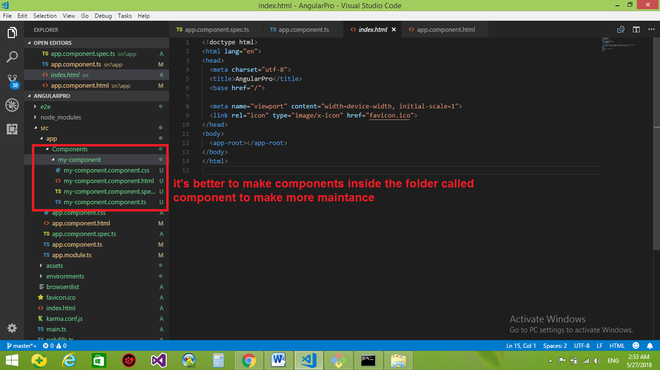

**3-we see after execution the command, we see that it create the component under the folder components with the basic 4 files**

**And add the component in the app.module.ts**

import { BrowserModule } from '@angular/platform-browser';

import { NgModule } from '@angular/core';

//we see that it add automatically the component MyComponentComponent

//we mean MyComponentComponent = MyComponent / Component.ts , but they not add .ts extension

import { AppComponent } from './app.component';

import { MyComponentComponent } from './Components/my-component/my-component.component';

@NgModule({

//we see that ther add the MyComponentComponent in the decleration

declarations: [

AppComponent,

MyComponentComponent],

//this part is used to import from the Rest API , PHP , ...

imports: [

BrowserModule],

//Used For Connect to firebase , etc.....

providers: [],

bootstrap: [AppComponent]})

export class AppModule { }

**To Add Component to the base Component**

**1-In the myComponent.component.ts you see the following**

import { Component, OnInit } from '@angular/core';

@Component({

selector: 'app-my-component',

templateUrl: './my-component.component.html',

styleUrls: ['./my-component.component.css']

})

export class MyComponentComponent implements OnInit {

constructor() { }

ngOnInit() {

}

}

**2-In the app.component.html we put the selector inside the app.component.html**

We see that we add the selector of the app-my-component into the app.component.html

<app-my-component></app-my-component>

<div style="text-align:center">

<h1>

Welcome to {{ title }}!

</h1>

</div>

<h2>Here are some links to help you start: {{Msg}}</h2>

<ul>

<li>

<h2><a target="_blank" rel="noopener" href="https://angular.io/tutorial">Tour of Heroes</a></h2>

</li>

<li>

<h2><a target="_blank" rel="noopener" href="https://github.com/angular/angular-cli/wiki">CLI Documentation</a></h2>

</li><li>

<h2><a target="_blank" rel="noopener" href="https://blog.angular.io/">Angular blog</a></h2></li>

</ul>>